K-number | K23014630
Module Title and Code  (e.g., Psychology and the Brain 4PAHPBIO) | 5PAHPPSY Psychological Skills
Assignment Deadline | 10.30 am on April 11th, 2025
Question Attempted (if appropriate, e.g., Q3 Describe the ionic basis of the action potential) | R End of Skill Challenge
Submitted file name | 5PAHPPSY_K23014630_R Results Report
Please identify any one aspect of your answer for which you would like specific feedback comments (this could be a section of your answer, or how successfully you have incorporated previous feedback: please paste here the feedback that you referred to in preparing your answer, if applicable). | If the interpretation of results is clear and easy to understand.  Does the R script work and concise?

Declaration by Students
By submitting this work, I confirm that I have not commissioned this work from a third party, and it represents a genuine demonstration of my own skills and subject knowledge and is written using my own words. I understand that plagiarism, self-plagiarism, collusion, contract cheating and the inappropriate use of AI, which includes copying and pasting directly from generative AI tools into submitted work, are serious assessment offences, an allegation of which may lead to action being taken under the College’s Misconduct regulations.

I understand that King’s requires students to acknowledge appropriate use of AI tools in assessments. If you are in doubt about how AI may be used during your studies, please check with your module and/or programme lead. College-wide student guidance on AI use can be found here: Generative AI - Student guidance | King's College London (kcl.ac.uk) and there is also general guidance in the ‘Preparing Written Assessment’ document provided on the programme and module pages. Please review this document as well as any module specific guidance. Each statement below (1 through 3e) represents an appropriate use of generative AI and is allowed in the guidance. We ask you to tick these statements because knowing when and how students use these tools can help us identify the additional guidance you need and improve teaching to leverage the benefits of AI tools. You will not be penalised for using AI tools in this manner. Please mark an X next to all the statements below that apply regarding your use of AI in this assessment:

1. | Generative AI not used at all for this assessment
2. | Generative AI used for checking spelling, grammar, and formatting (but I confirm that the work submitted represents a genuine demonstration of my own skills and subject knowledge) | X
3. | Generative AI used to support learning (you may select multiple options if relevant): | X
 | (a) Generate ideas and/or structure suggestions
 | (b) Assist with understanding concepts/summarising sources (e.g. student lecture notes) to aid understanding
 | (c) Provide feedback on ideas to help improve learning/understanding
 | (d) Generate illustrative images (references should be provided for these within your main reference list)
 | (e) For coursework only: the use of generative AI has been acknowledged by including a declaration statement along with your references | X

Results
Pearson’s Product-Moment Correlation Analysis for Pure Tone Audiometry Scores
A Pearson’s product-moment correlation analysis was conducted to investigate the relationships between the PTA scores for the left and right ears at octave frequencies from 250 to 8000Hz, for 126 male and 144 female participants. Descriptive statistics for the PTA scores can be found in Table 1.

Table 1 - Descriptive Statistics for Pure Tone Audiometry Scores (PTA)
Pure Tone Audiometry Scores | Left |  |  | Right
 | Male | Female | Overall | Male | Female | Overall
Mean | 14.43 | 13.81 | 14.10 | 14.11 | 14.15 | 14.13
SD | 10.69 | 10.70 | 10.70 | 11.06 | 10.00 | 10.48

For male participants, the results indicated a strong positive correlation between PTA_Left and PTA_Right, r(124)=0.857, p < .001, 95% CI [0.802, 0.897]. This suggests that higher PTA_Left scores are associated with higher PTA_Right scores among male participants.
For female participants, the results indicated a strong positive correlation between PTA_Left and PTA_Right, r(142)=0.847, p < .001, 95% CI [0.793, 0.887]. This suggests that higher PTA_Left scores are associated with higher PTA_Right scores among female participants.
The scatterplot in Figure 1 shows the relationship between PTA_Left and PTA_Right scores for participants categorized by sex. Each point represents an individual participant's score, and the line represents the best-fit line for the data.

Figure 1 - Scatterplot of PTA_Left and PTA_Right Scores for Participants by Sex
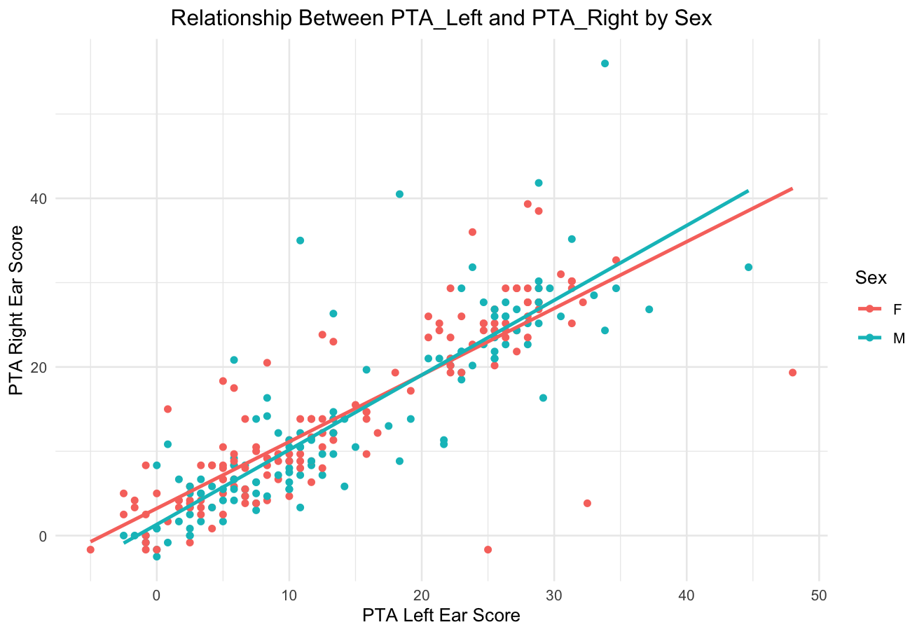

One-Way Repeated Measures ANOVA
A one-way repeated measures ANOVA test was conducted to investigate whether there is a difference in response accuracy for Clear, Compressed, Noise, and Vocoded conditions.
The results indicated a significant effect of condition on accuracy, F(3, 1072) = 171.77, p < .001, η² = 0.14. The grand mean accuracy across all conditions was 68.84 (SD = 9.65).
Table 1 presents descriptive statistics for each condition. The mean accuracy scores for the clear condition were M = 87.2, SD = 7.82, for the Compressed condition M = 79.7, SD = 9.90, for the Noise condition M = 58.1, SD = 14.9, and for the Vocoded condition M = 50.3, SD = 14.9. Figure 1 below shows the boxplot of accuracy across the four conditions.

Table 1 - Mean Accuracy and Standard Deviation by Condition
Condition | Mean Accuracy | Standard Deviation
Acc_Clear | 87.2 | 7.82
Acc_Compressed | 79.7 | 9.90
Acc_Noise | 58.1 | 14.9
Acc_Vocoded | 50.3 | 14.9
Overall Across All Conditions | 68.84 | 9.65

To further investigate the differences in accuracy between conditions, pairwise comparisons using paired t-tests were conducted. All pairwise comparisons were statistically significant (p < .001), indicating that accuracy differed significantly across all conditions. The t-test results are presented in Table 2.
Table 2 - Paired T-Test Results from One-Way Repeated Measures ANOVA

Comparison | t(538) | p-level | Mean Difference | SD |  | Cohen’s d | 95% Confidence Interval
 |  |  |  | First Condition | Second Condition |  | Lower | Upper
Clear vs.  Noise | 45.96 | < .001 | 29.03 | 7.82 | 14.86 | 2.44 | 27.78 | 30.27
Clear vs. Vocoded | 52.39 | < .001 | 36.85 | 7.82 | 14.85 | 3.10 | 3546 | 38.23
Clear vs. Compressed | 14.90 | < .001 | 7.42 | 7.82 | 9.90 | 0.83 | 6.44 | 8.40
Noise vs. Vocoded | 8.90 | < .001 | 7.82 | 14.86 | 14.85 | 0.53 | 6.09 | 9.55
Noise vs. Compressed | -29.98 | < .001 | -21.61 | 14.86 | 9.90 | -1.71 | -23.03 | -20.19
Vocoded vs. Compressed | -35.32 | < .001 | -29.43 | 14.85 | 9.90 | -2.33 | -31.07 | -27.79

Note: Cohen's d is interpreted as follows: small (0.2), medium (0.5), and large (0.8) effect sizes.

The degrees of freedom for each comparison are estimated based on the assumption of equal sample sizes for each condition (e.g., 270 participants per condition).

Figure 2 - Boxplot of Differences between the Accuracy of Responses for the Four Conditions (Clear, Compressed, Noise, Vocoded)
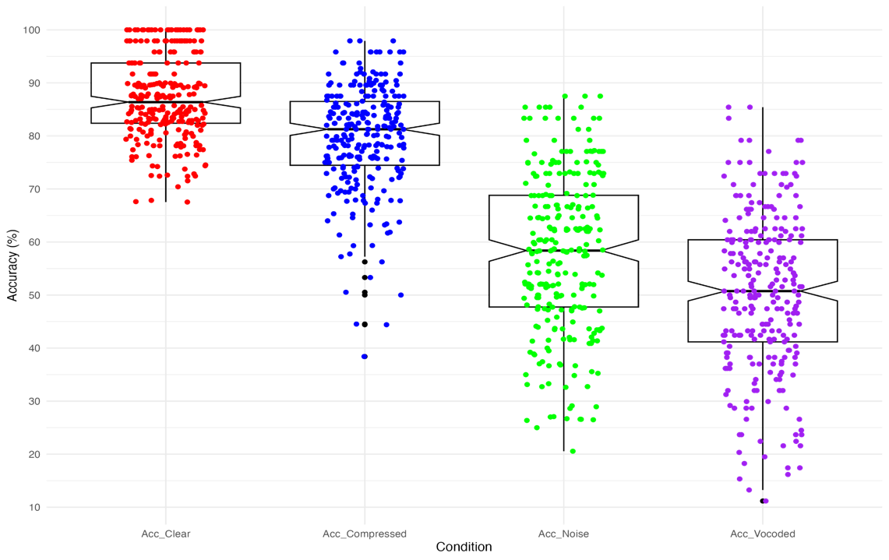

Two-Way Mixed ANOVA
A mixed-design analysis of variance (ANOVA) was conducted to examine the effects of condition and age group on response time, with condition as a within-subjects factor and age group as a between-subjects factor.
The analysis revealed a significant main effect of condition on response time, F(3, 1064) = 61.94, p < .001, partial η² = .15, 95% CI [.12, 1.00]. This indicates that the experiment al conditions substantially impacted participants' response times.
No significant main effect was found for age group, F(2, 1064) = 1.28, p = .279, partial η² = .002, 95% CI [.00, 1.00], suggesting that response times did not differ significantly across different age groups.
Additionally, the interaction between condition and age group was not significant, F(6, 1064) = 1.34, p = .239, partial η² = .007, 95% CI [.00, 1.00], indicating that the effect of condition on response time was consistent across all age groups.
Response times were consistent across all age groups. Follow-up pairwise comparisons with Bonferroni post-hoc correction revealed significant differences in response times between the various conditions.
Table 3 -Paired T-Tested Results from Two-Way Mixed ANOVA

Reaction Time Comparisons | t(538) | p-level | Mean Difference | SD |  | Cohen’s d | 95% Confidence Interval
 |  |  |  | First Condition | Second Condition |  | Lower | Upper
Clear vs.  Noise | -8.18 | < .001 | -157.00 | 207.82 | 237.28 | -0.70 | -194.71 | -119.29
Clear vs. Vocoded | -19.40 | < .001 | -340.18 | 207.82 | 199.66 | –1.67 | -374.64 | -305.73
Clear vs. Compressed | -22.52 | < .001 | -419.44 | 207.82 | 224.76 | -1.94 | -456.04 | -456.04
Noise vs. Vocoded | -9.71 | < .001 | -183.18 | 237.28 | 199.66 | -0.84 | -220.26 | -220.26
Noise vs. Compressed | 13.19 | < .001 | -262.44 | 237.28 | 224.76 | -1.14 | 223.37 | 223.37
Vocoded vs. Compressed | 4.33 | < .001 | -79.26 | 199.66 | 224.76 | -0.37 | 43.32 | 115.20

Note: Cohen's d is interpreted as follows: small (0.2), medium (0.5), and large (0.8) effect sizes.

The degrees of freedom for each comparison are estimated based on the assumption of equal sample sizes for each condition (e.g., 270 participants per condition).
Specifically, response times were significantly faster in the Clear condition compared to the Compressed, Noise, and Vocoded conditions (all p <.001). The Compressed condition exhibited substantially quicker response times than the Noise and Vocoded conditions (all p < .001). Finally, response times in the Noise condition were considerably faster than in the Vocoded condition ( p < .001).
These results suggest that while the condition significantly affected both response times and accuracy, age did not play a significant role in performance differences. The substantial effect size for condition (partial η² =.15) highlights the practical significance of these findings, demonstrating how different auditory processing conditions impact performance regardless of age.
Figure 3 presents a bar chart with error bars comparing response times (in milliseconds) across four auditory conditions (Clear, Compressed, Noise, and Vocoded) between three age groups (Younger, Middle, Older). The chart is faceted by age group, with each panel displaying the four conditions.

Figure 3 - Bar Chart Illustrating Response Times across Listening Conditions by Age Group
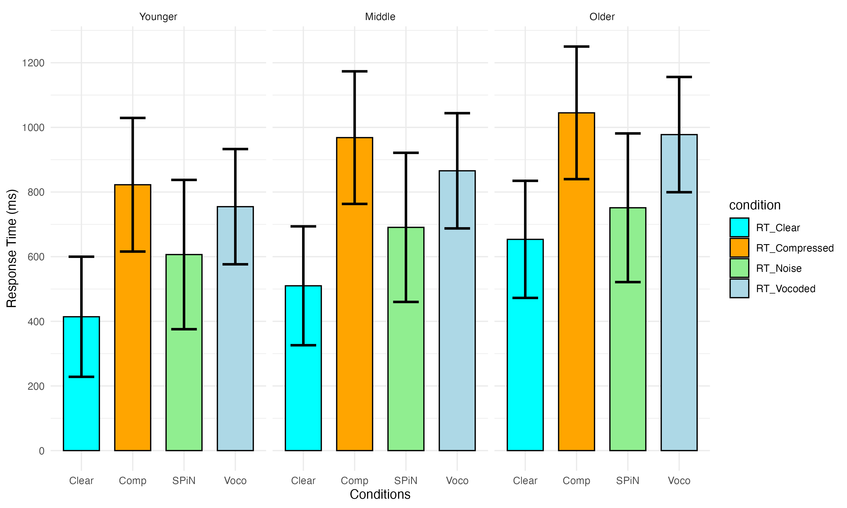
Note: Error bars represent ±1 standard deviation from the mean. Clear = clear speech condition; Comp = compressed speech condition; SPiN = noise condition; Voco = vocoded speech condition.

These results suggest that while condition significantly affected both response time and accuracy, age did not play a significant role in performance differences. The substantial effect size for condition (partial η² = .15) highlights the practical significance of these findings, demonstrating how different auditory processing conditions impact performance regardless of age.

Declarative Statement
I declare that parts of this submission has contributions from AI software and that it aligns with acceptable use as specified as part of the assignment brief/ guidance and is consistent with good academic practice. The content can still be considered as my own words. I understand that as long as my use falls within the scope of appropriate use as defined in the assessment brief/guidance then this declaration will not have any direct impact on the grades awarded.
I acknowledge use of software to:
(iii) Generate some other aspect of the submitted assessment.
I used ChatGPT to develop and validate code for generating and reporting comprehensive t-test results. This includes reporting not only the Bonferroni-adjusted p-values taught in our practical sessions but also essential statistics such as degrees of freedom, confidence intervals, standard deviations, and mean differences. I aimed to adhere to APA style guidelines for reporting statistical results, which extend beyond what was covered in the practical sessions.

